IG Sports Coaching Ltd
Complaints Handling Policy

Our complaints policy
We are committed to providing a high-quality legal service to all our clients. When something goes wrong, we need you to tell us about it. This will help us to improve our standards.

If you have a complaint, please contact us with the details. We have eight weeks to consider your complaint. If we have not resolved it within this time you may complain to the Legal Ombudsman.
What will happen next?
- We will send you a letter acknowledging receipt of your complaint within three days of receiving it, enclosing a copy of this procedure.

- We will then investigate your complaint. This will normally involve passing your complaint to Ian Groves who will review your matter file and speak to the member of staff who acted for you.

- Ian Groves will then invite you to a meeting to discuss and hopefully resolve your complaint. He will do this within 14 days of sending you the acknowledgement letter.

- Within three days of the meeting, Ian Groves will write to you to confirm what took place and any solutions He has agreed with you.

- If you do not want a meeting or it is not possible, Ian Groves will send you a detailed written reply to your complaint, including his suggestions for resolving the matter, within 21 days of sending you the acknowledgement letter.

- At this stage, if you are still not satisfied, you should contact us again and we will arrange for Ofsted to review his own decision to review the decision.

- We will write to you within 14 days of receiving your request for a review, confirming our final position on your complaint and explaining our reasons.

- If you are still not satisfied, you can then contact the
Legal Ombudsman,  PO Box 6806,  Wolverhampton  WV1 9WJ | Ofsted,  Piccadilly Gate  Store Street  Manchester  M1 2WD  0300 123 1231

About your complaint. Normally, you will need to bring a complaint to the Legal Ombudsman within six months of receiving a final written response from us about your complaint or within six years of the act or omission about which you are complaining occurring (or if outside of this period, within three years of when you should reasonably have been aware of it). For further information, you should contact the Legal Ombudsman on 0300 555 0333 or at enquiries@legalombudsman.org.uk.

Name: Ian Groves
Position: Director
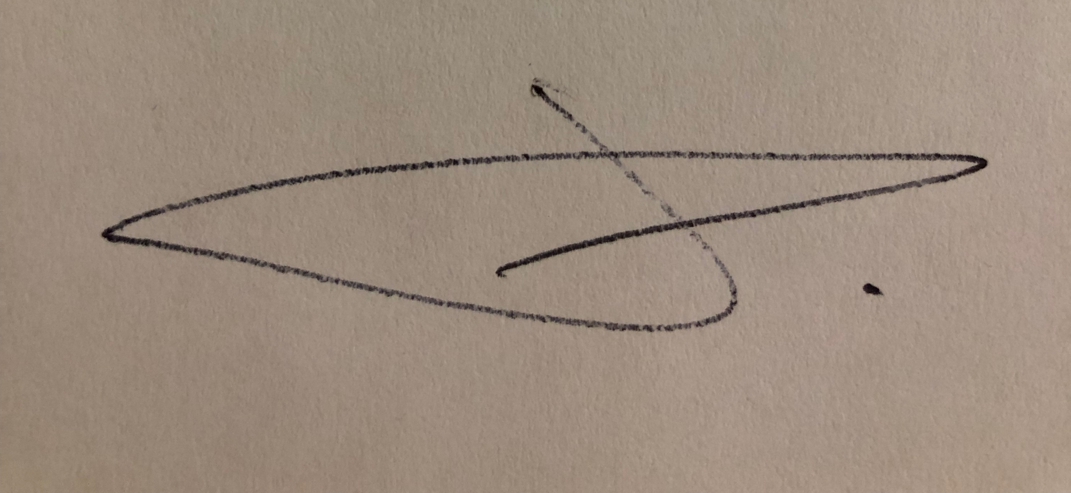
Date: 18/02/2019

Signature:

